**Name**

**Advanced Programming in Java**

**Lab Exercise 11/1/2024**

1. Do you like treasure hunts? In this problem you are to write a program to explore the above array for a treasure. The values in the array are clues. Each cell contains an integer between 11 and 55; for each value the ten's digit represents the row number and the unit's digit represents the column number of the cell containing the next clue. Starting in the upper left corner (at 1,1), use the clues to guide your search of the array. (The first three clues are 11, 34, 42). The treasure is a cell whose value is the same as its coordinates. Your program must first read in the treasure map data into a 5 by 5 array. Your program should output the cells it visits during its search, and a message indicating where you found the treasure.

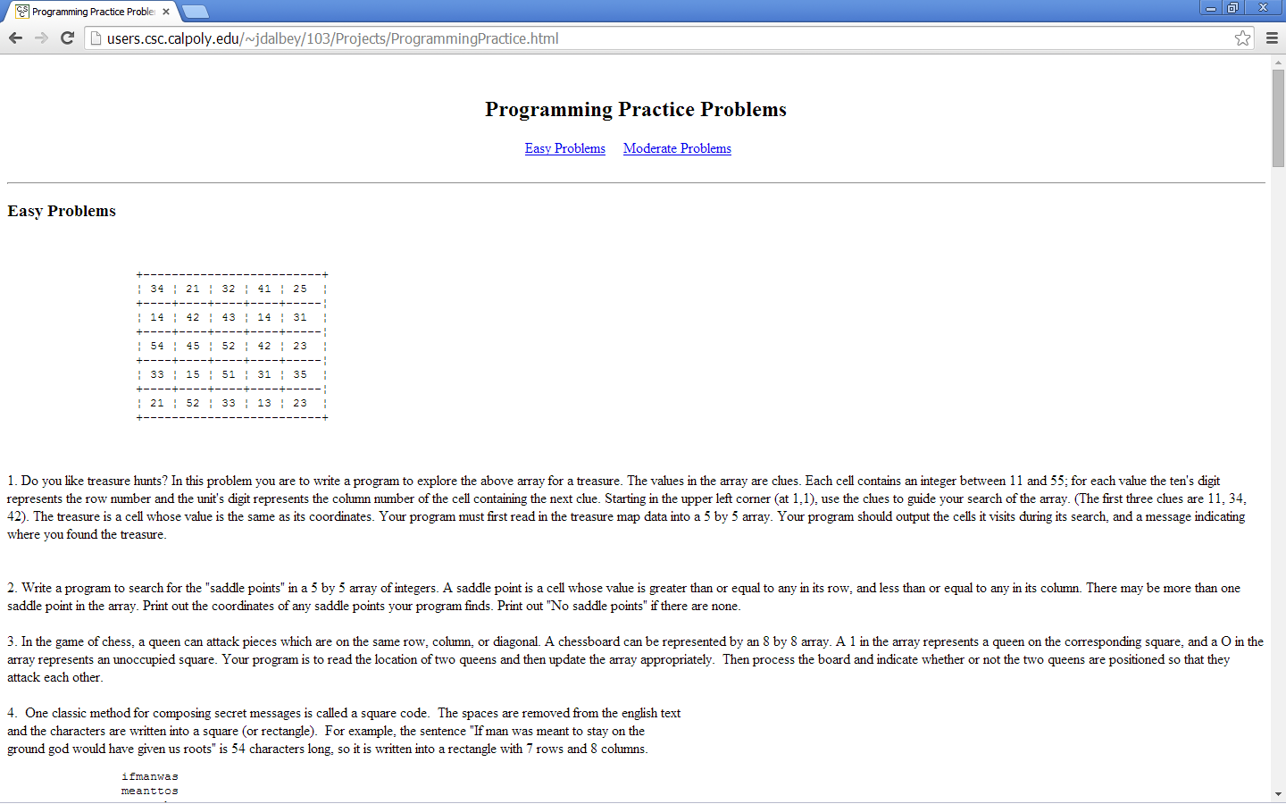

On the server, you will find a text file with these values that you can load in to your 2D array.

**Note: Java arrays are 0 based and locations in this array are not.**

Once your program has read in the array it should searching it for treasure reporting each location the treasure hunter is located and when it finds the treasure.

1. For faster sorting of letters, the USPS encourages companies that send large volumes of mail to use a bar code denoting the zip code. The encoding scheme for a five digit zip code is as follows:

* There are one full height frame bars on each side |
* The five encoded digits are followed by a check digit.
* The check digit is the value that makes the sum of all of the digits be a multiple of 10.
* Each digit of the zip code and the check digit is encoded according to the following table.

|  |  |
| --- | --- |
| 1 | :::|| |
| 2 | ::|:| |
| 3 | ::||: |
| 4 | :|::| |
| 5 | :|:|: |
| 6 | :||:: |
| 7 | |:::| |
| 8 | |::|: |
| 9 | |:|:: |
| 0 | ||::: |

Where | denotes a full bar and : denotes a half bar.

Write a program that asks the user for a zip code and prints the bar code. For example:

95014 becomes ||:|:::|:|:||::::::||:|::|:::|||

Provide the following methods:

void static printDigit (int d)

void static printBarCode(String zipCode)

**When your programs are complete, submit your source code as well as the output from your program.**